Assignment 1 solutions

1. Solution:

Touch cmd is used to create directory in Linux.

MV cmd is used to move file current path to another path in linux

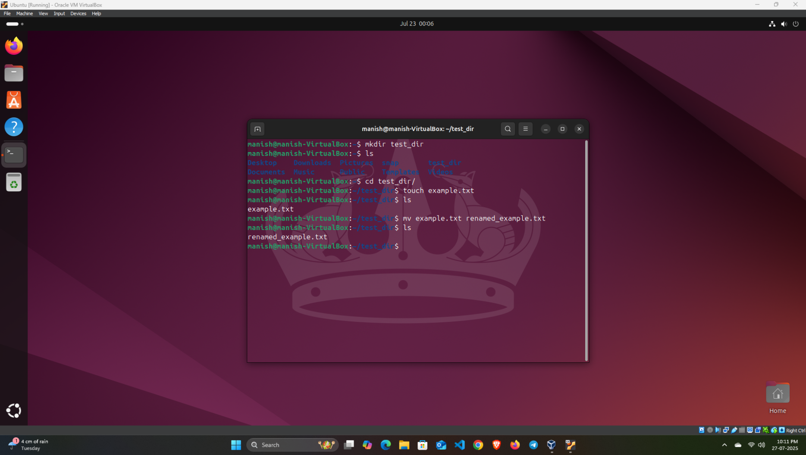

1. Solution:

cat cmd is used to display the content of file in terminal

head cmd is used to display content from the top

tail cmd is used to display content from the bottom.

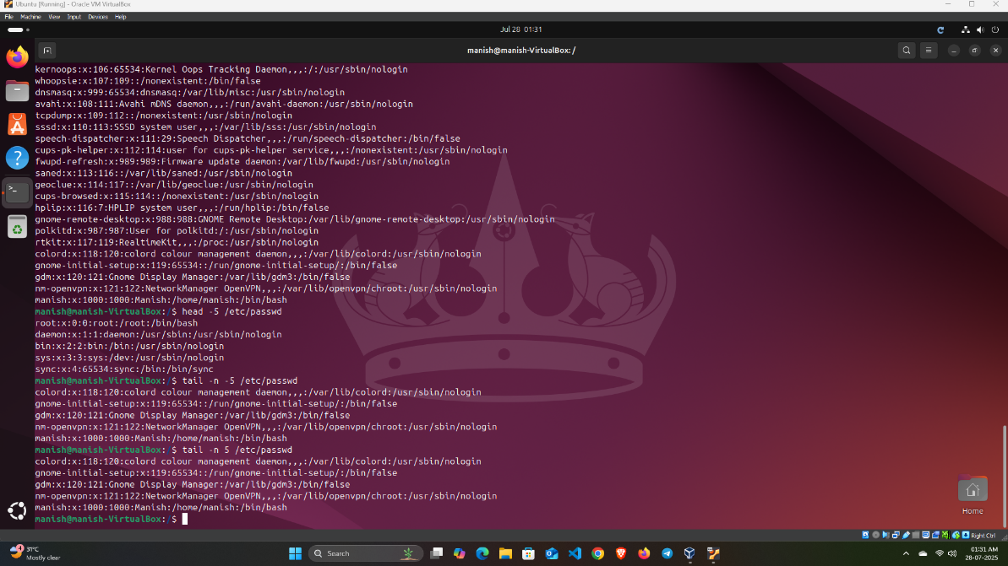

3.Solution:

Grep cmd is used for searching a string within an output

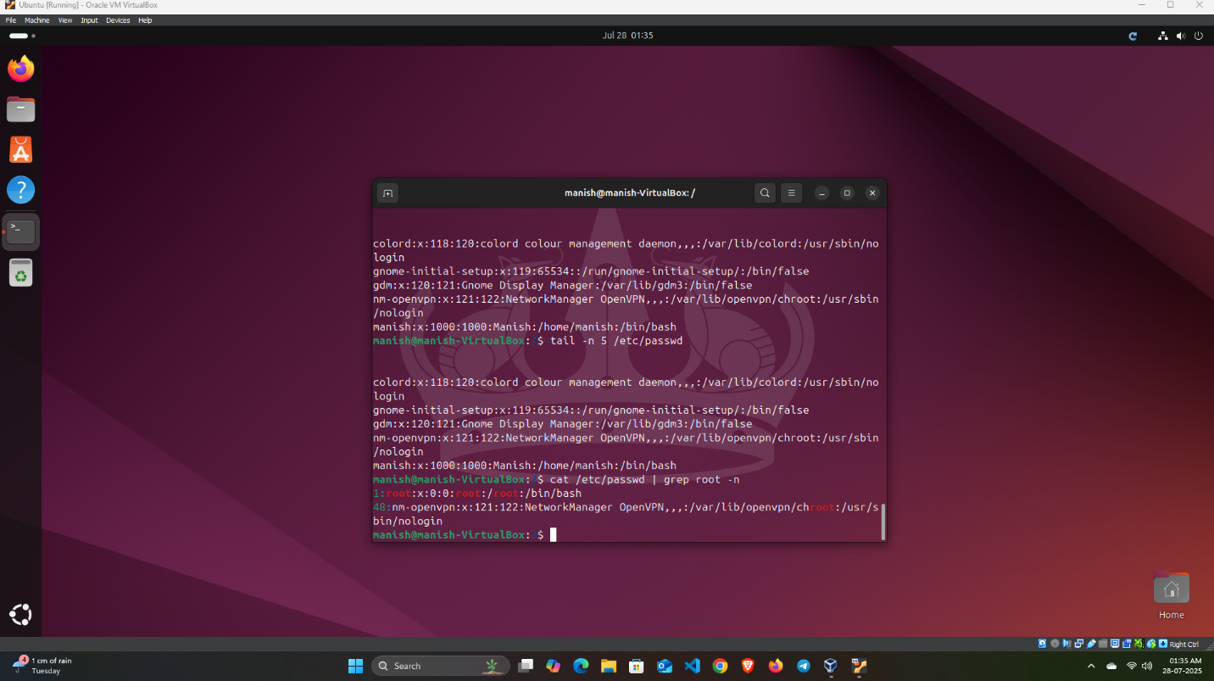

4.Solution:

Zip and unzip in Linux.

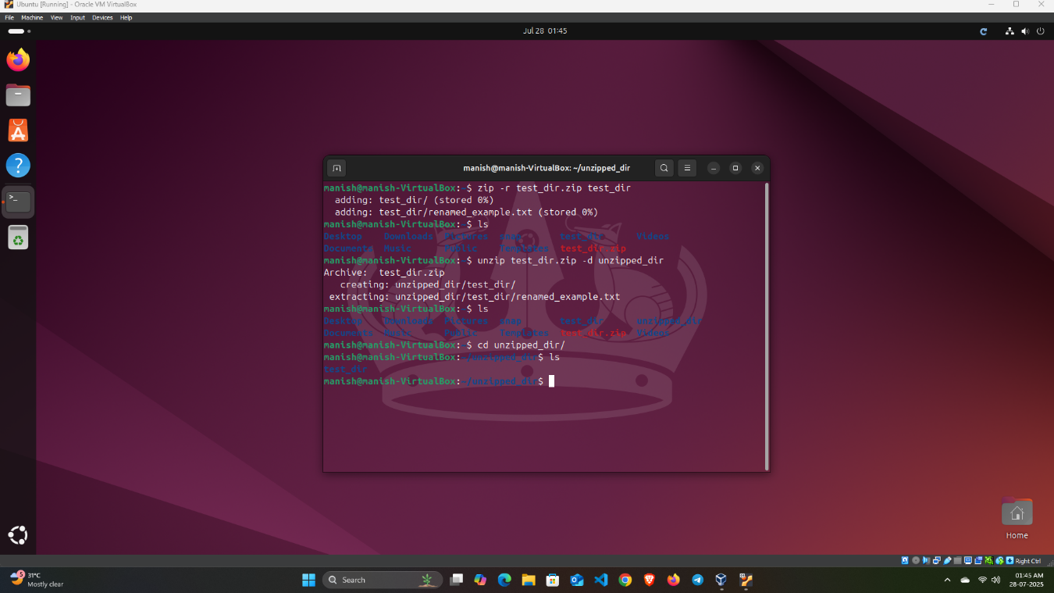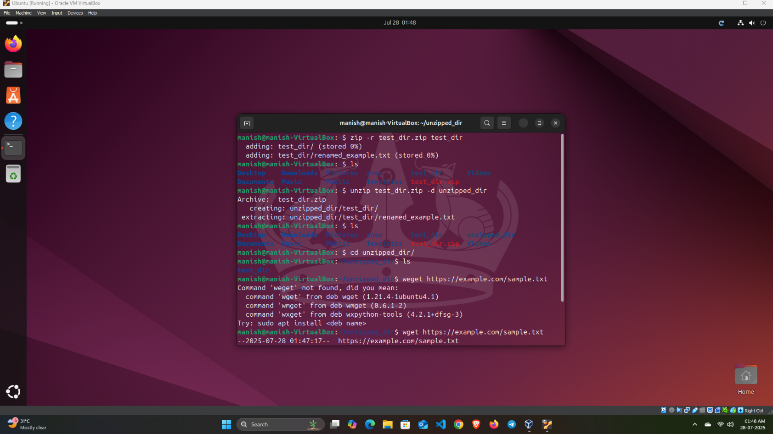

5. Solution:

Downloading files(script.js) through ‘wget’ cmd

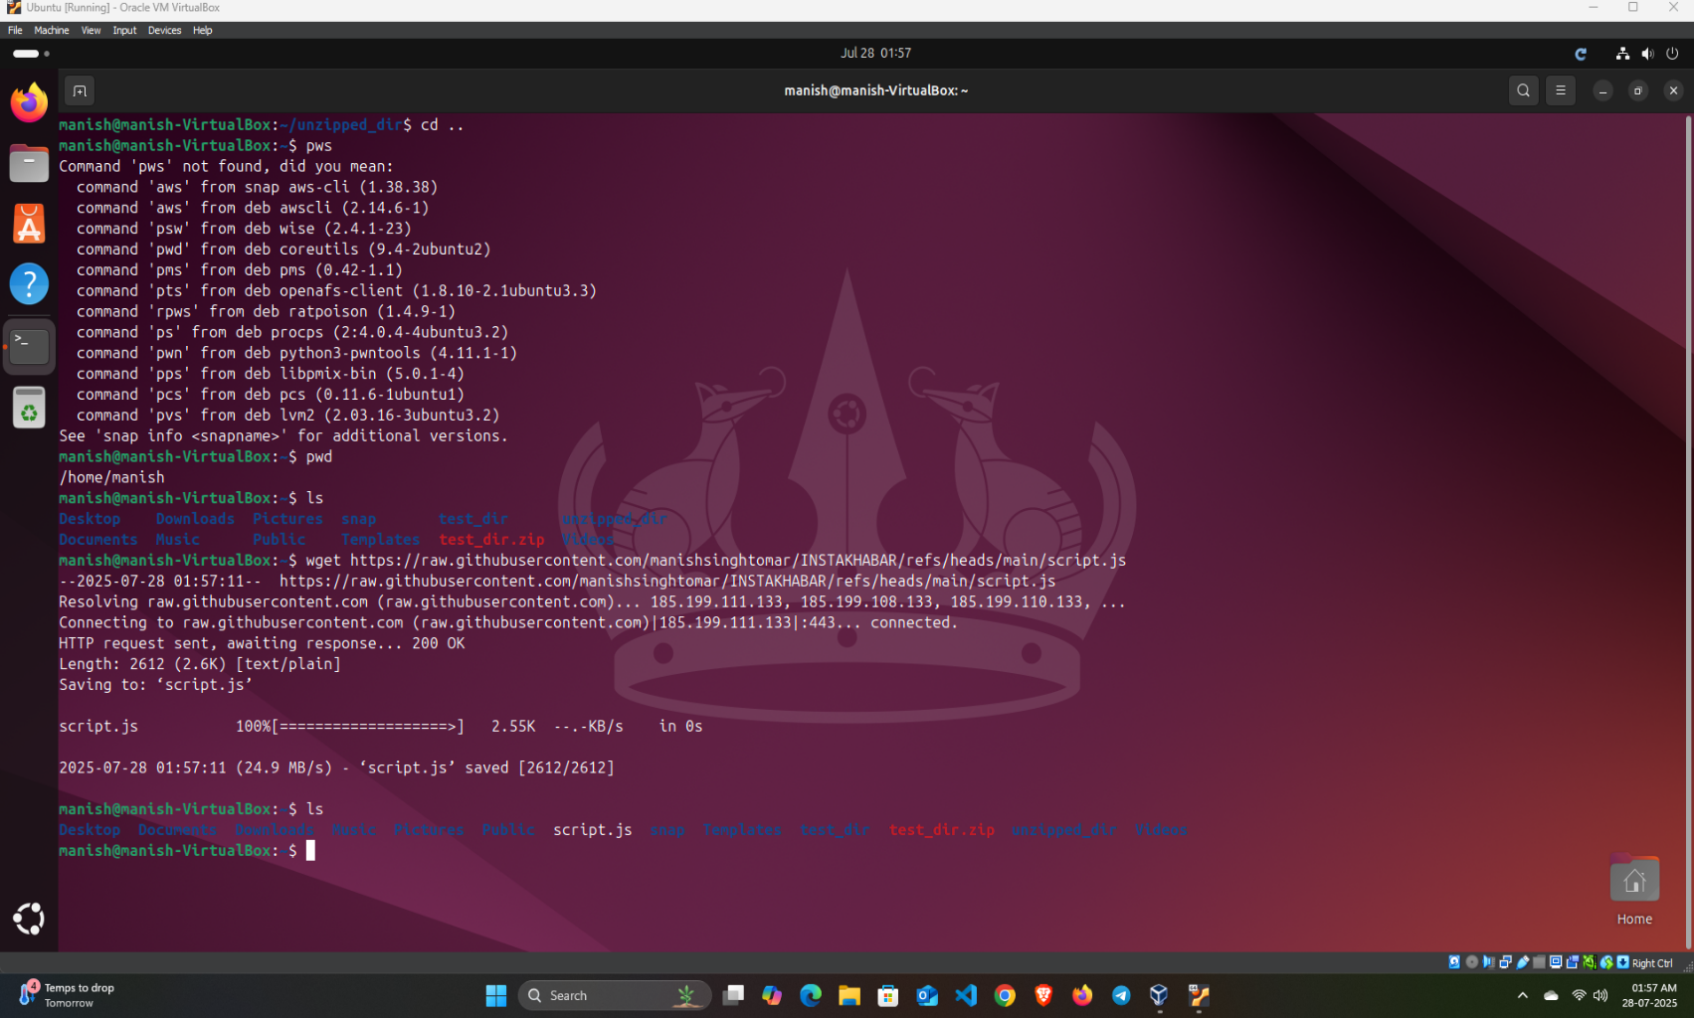

6. Solution:

Chmod cmd is used to change the permissions of files in Linux.

Secure.txt is created by touch command

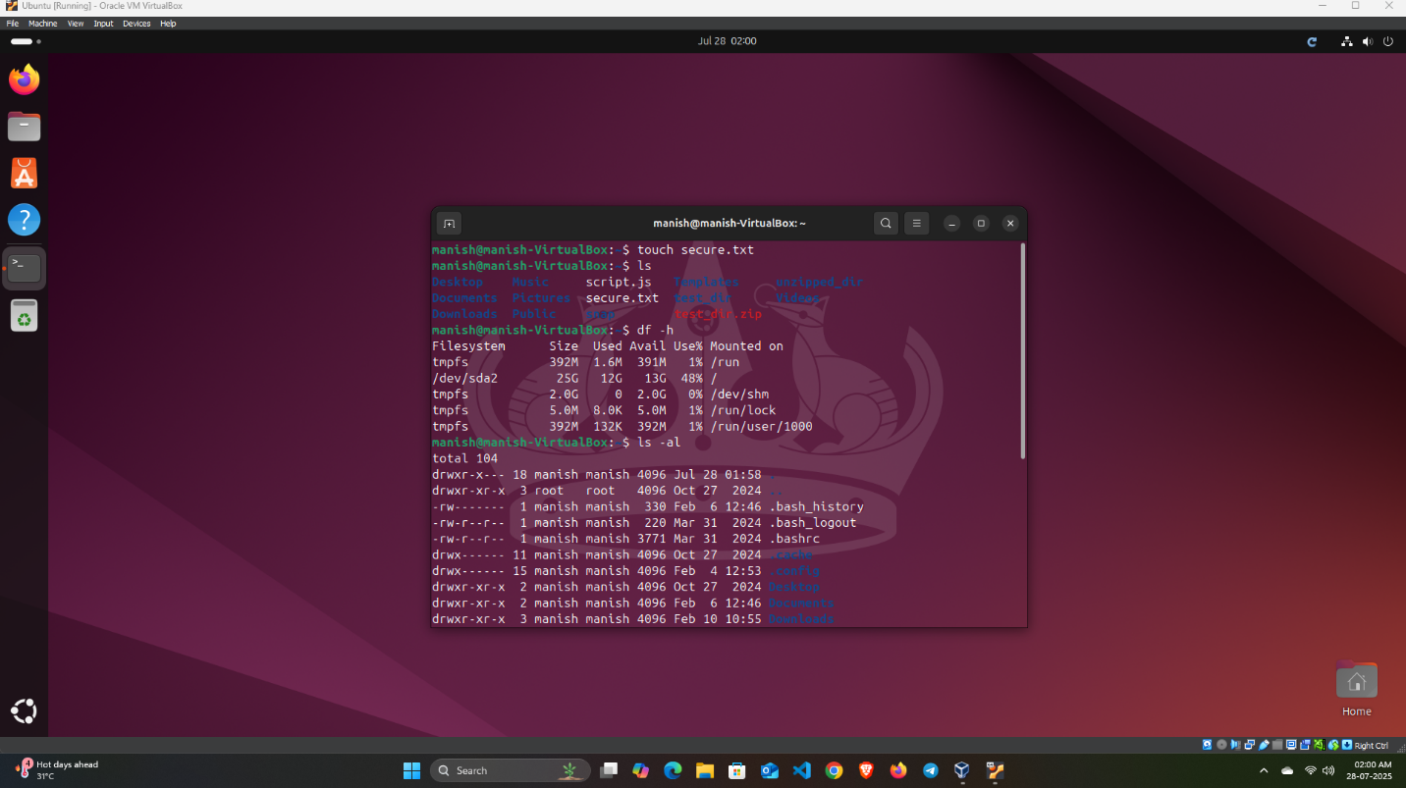

Chmod a-wx secure.txt

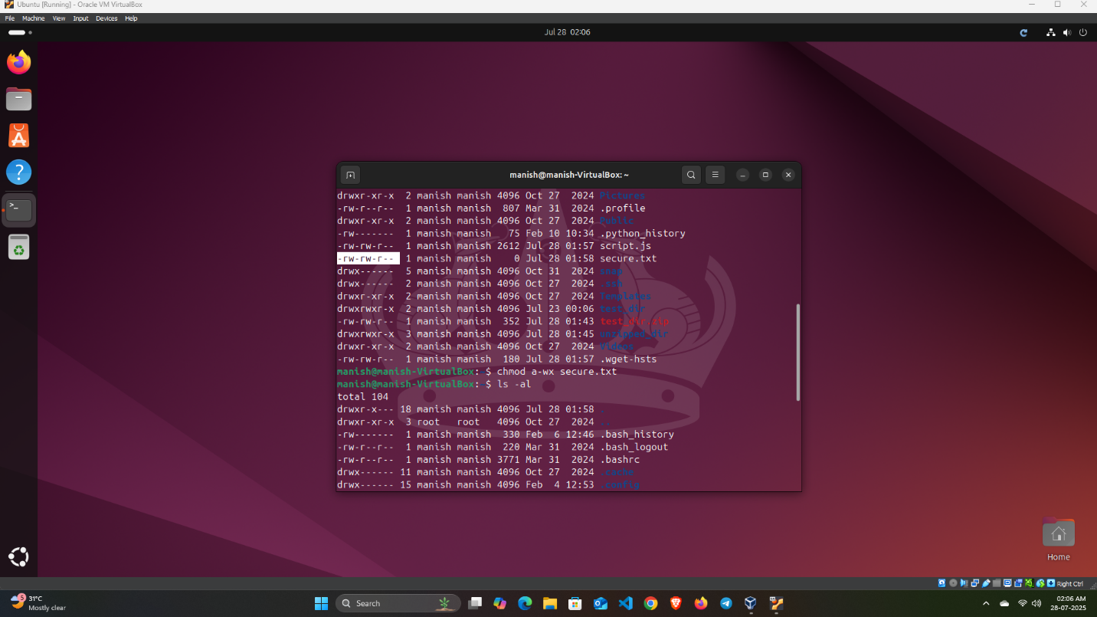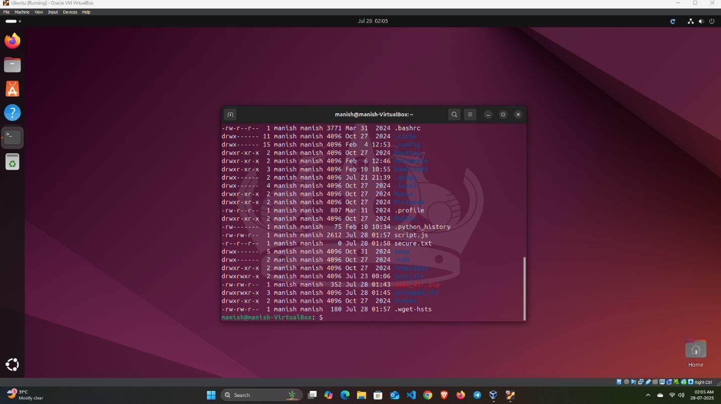

7.Solution:

Export command is used to set environment variable in linux.

